Name: Jay Rajesh Umap

Roll No.: 2205010

Enrollment No.: MITU20BTIT0029

Class: LY IT Core

Lab Assignment No.: 1. Creating instance of virtual machine in any virtualization software.

What is VirtualBox?

VirtualBox is a free software that allows you to run multiple operating systems (like Windows, Linux, or macOS) simultaneously on a single physical computer. It's useful for tasks like software testing, creating safe environments for risky applications, or learning about different operating systems without needing separate hardware. VirtualBox provides isolation and resource management for these virtual machines, making it a versatile tool for various purposes.

Each VM functions as an independent computer, complete with its own operating system and applications. This versatility is invaluable for several reasons. Software developers and testers can use VirtualBox to simulate various environments, ensuring compatibility across different platforms. It's also useful for creating isolated environments for potentially risky applications, enhancing security. Additionally, VirtualBox is employed in education for teaching operating system concepts and in businesses to save hardware costs by running multiple servers on a single machine.

* Cross-Platform: VirtualBox is compatible with a wide range of host operating systems, including Windows, Linux, macOS, and more. This flexibility allows users to run virtual machines on different host platforms.
* Guest OS Support: It supports various guest operating systems, such as Windows, Linux distributions, macOS, BSD, and others. This makes it versatile for running different types of software and applications.
* Hardware Virtualization: VirtualBox supports hardware-assisted virtualization, which improves performance by allowing virtual machines to directly access the host's CPU and memory resources when available.
* Snapshot and Clone: Users can take snapshots of virtual machines at specific points in time. These snapshots serve as backups and can be restored if issues arise during testing or configuration changes. Cloning VMs is also possible, making it easy to replicate setups.
* Modularity: VirtualBox has a modular architecture, allowing users to add extensions and customize the software to meet specific requirements. Extensions can add features like support for USB devices or remote desktop access.

Steps:

1. Installing and Setting up Oracle VirtualBox (<https://www.virtualbox.org/>)

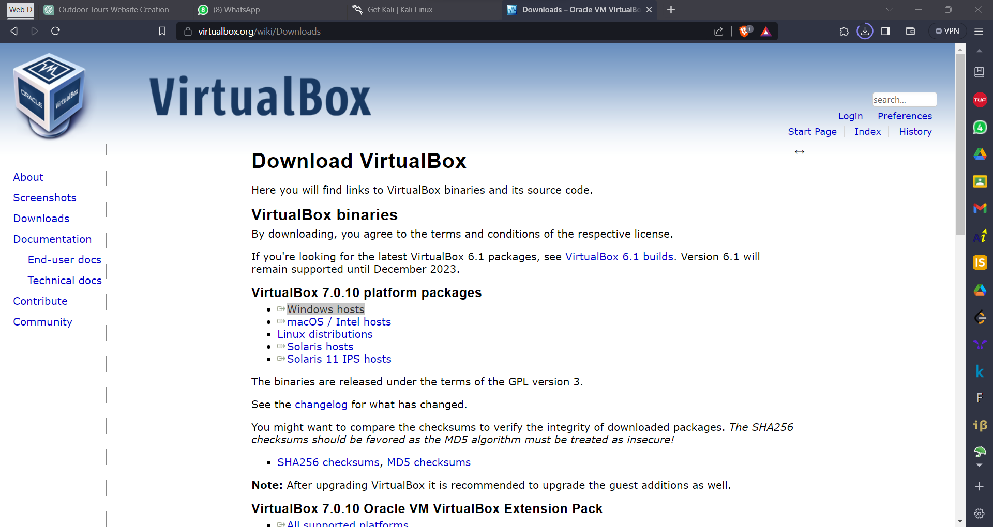

1. 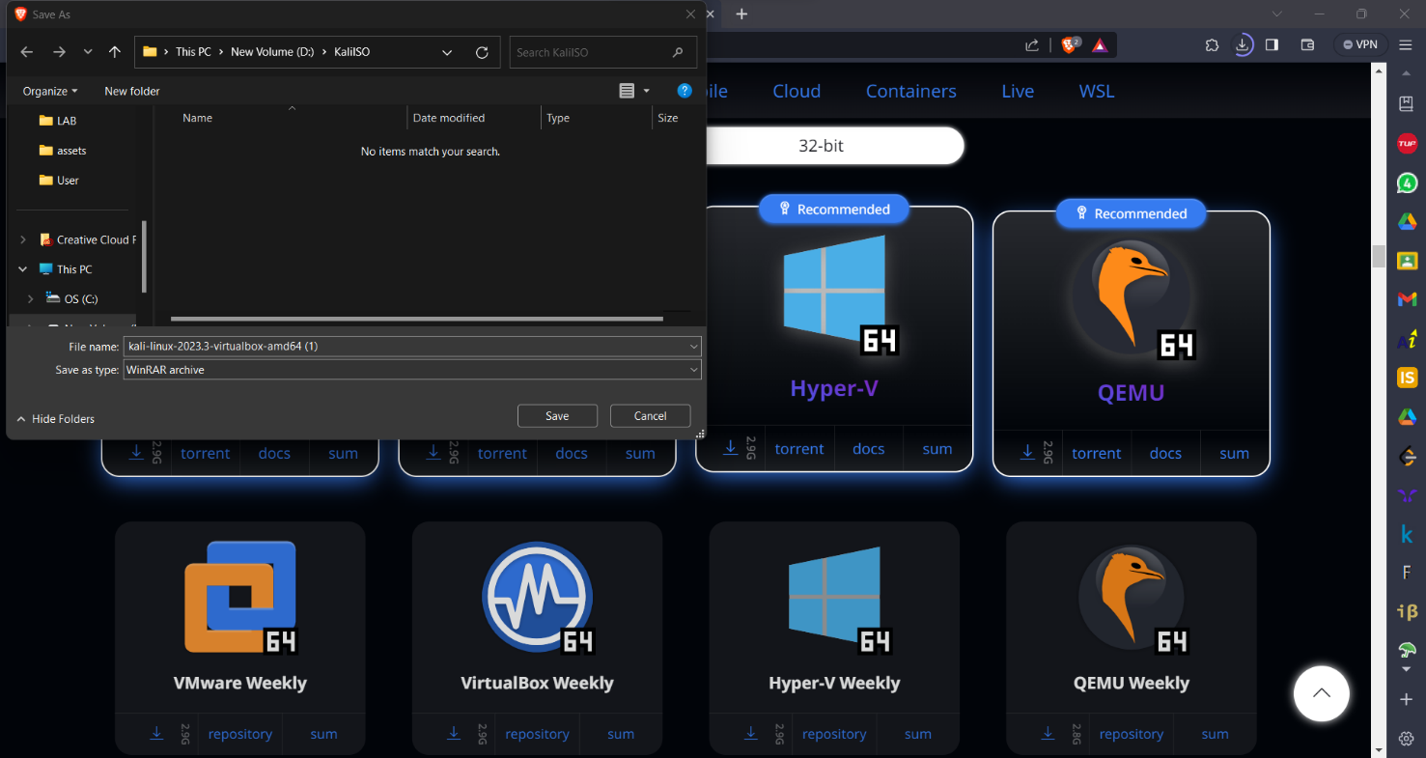Installing iso file of required OS
2. Open VirtualBox after setup and click on new on top to add iso file and setup OS location

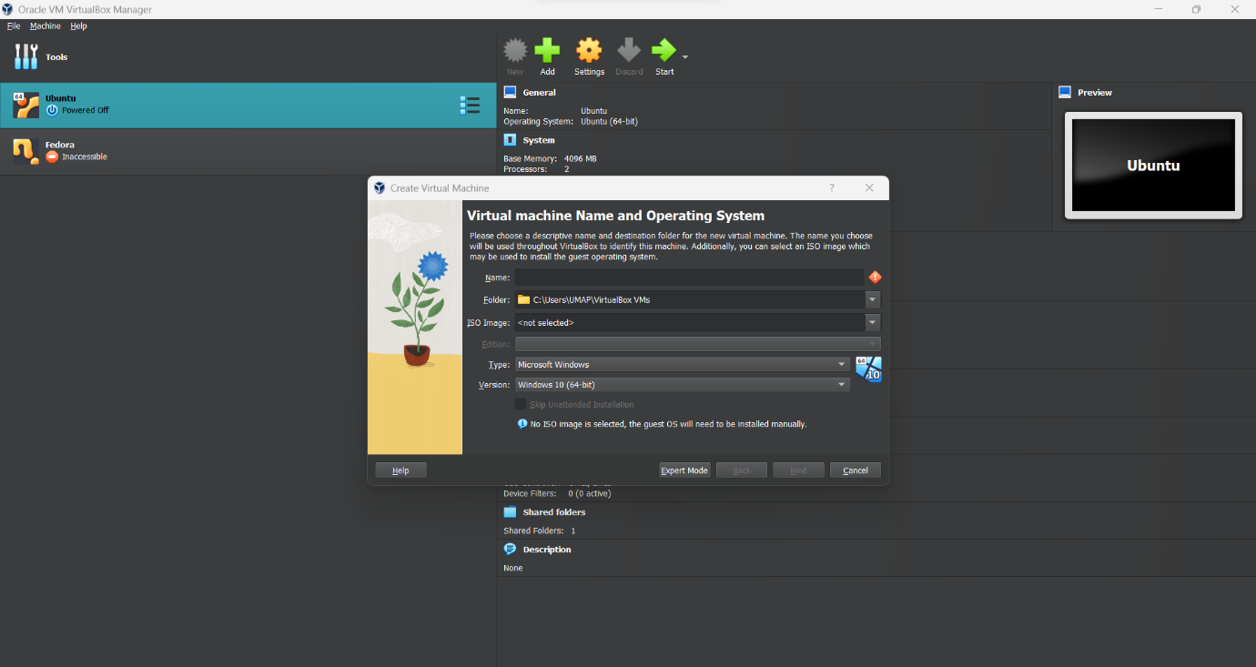

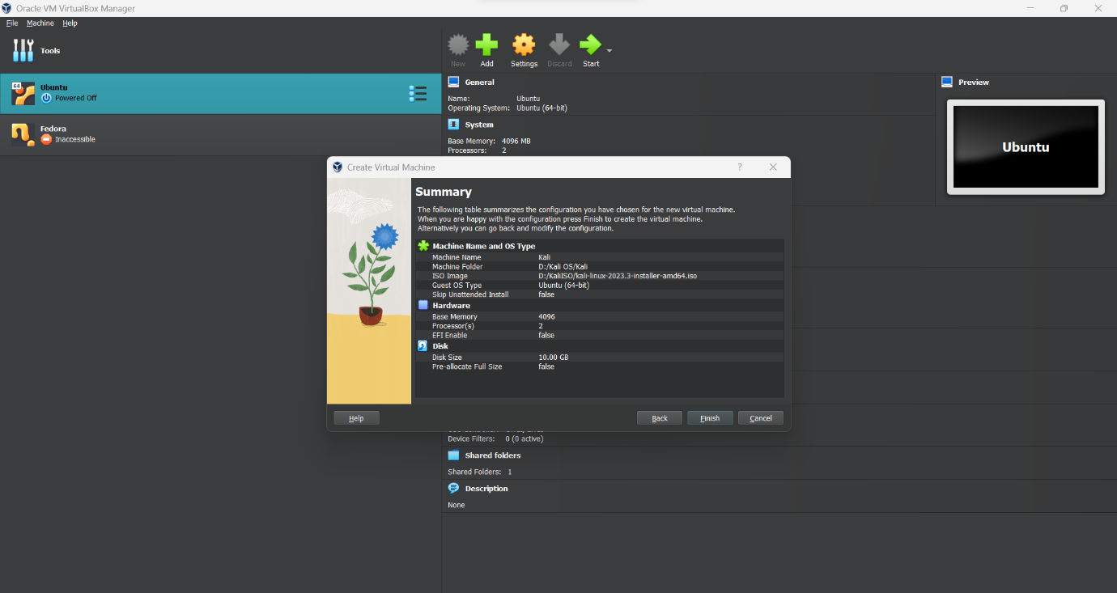

Provide all necessary system specification and storage access to virtual OS and install OS

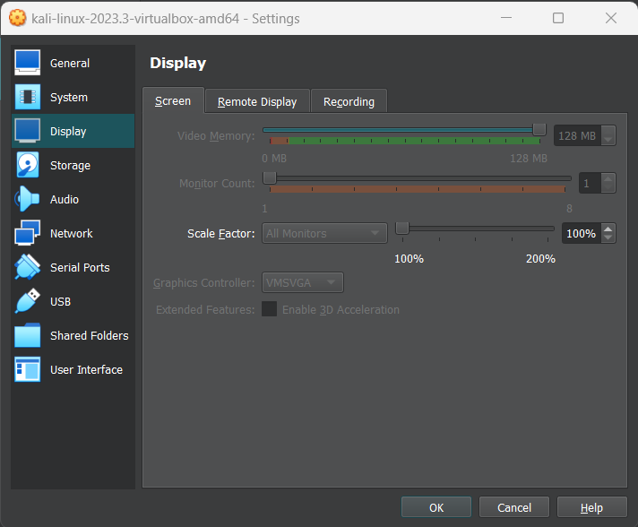

1. Installation begins

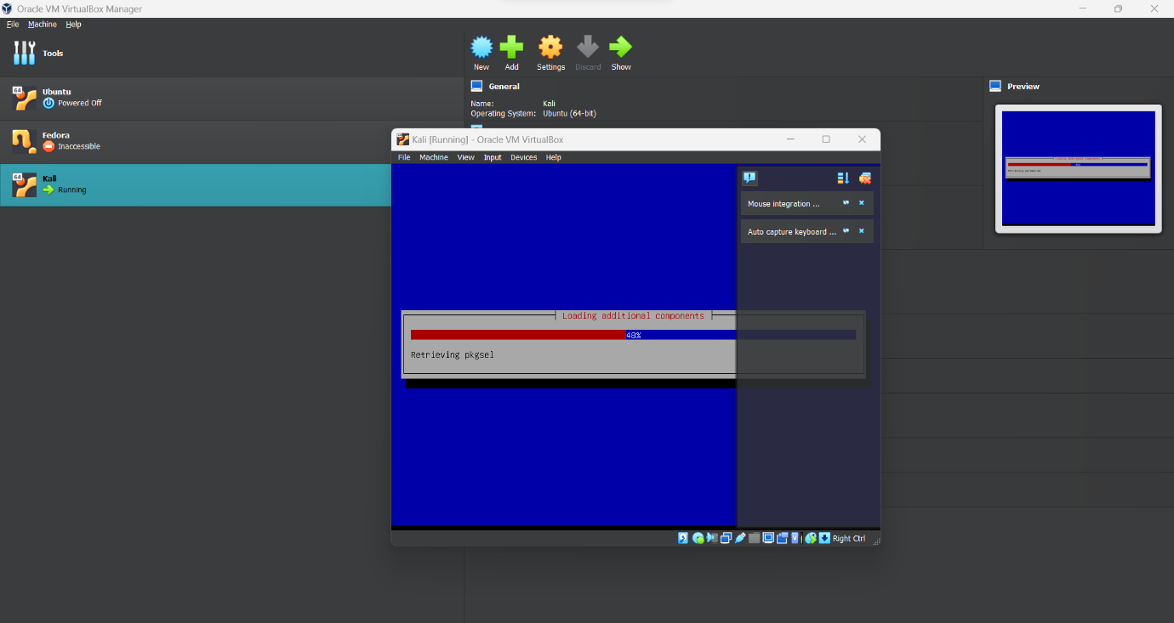

1. Boot Virtual OS in VirtualBox

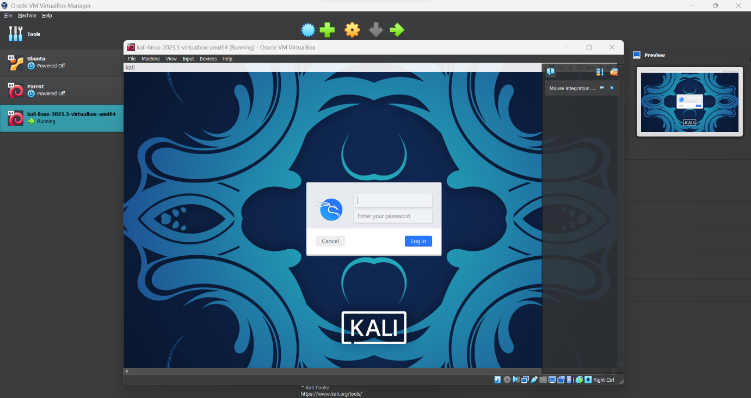

1. Installation completed

